**CAPACITIVE REACTANCE**

**LAB # 02**



**Fall 2022**

**CSE-203L**

**Circuits & System-2 Lab**

Submitted by: **NAVEED AHMAD**

Registration No.: **22PWCSE2165**

Class Section: **B**

“On my honor, as student of University of Engineering and Technology, I have neither given nor received unauthorized assistance on this academic work.”

Student Signature: ______________

Submitted to:

**Engr. Usman Malik**

Nov.2023

Department of Computer Systems Engineering

University of Engineering and Technology, Peshawar

**Objective:**

Explore capacitive reactance, examining its correlation with capacitance and frequency. Generate a capacitive reactance versus frequency plot through experimental investigation.

**Theory Overview:**

The current-voltage behaviour of capacitors, unlike resistors, exhibits a unique characteristic. Capacitive reactance (Xc), the equivalent ohmic value for a capacitor, is inversely proportional to frequency. This relationship is mathematically expressed as Xc = 1/(2πfC), where f is frequency and C is capacitance. Experimental determination involves applying a known current to a capacitor, measuring the resulting voltage, and calculating reactance using Ohm's Law. This process is repeated across various frequencies for a comprehensive Xc versus frequency plot.

**Equipment:**

1. AC function generator
2. Oscilloscope
3. Capacitors: 1µF and 2.2µF
4. Resistor: 10kΩ

Fig 01

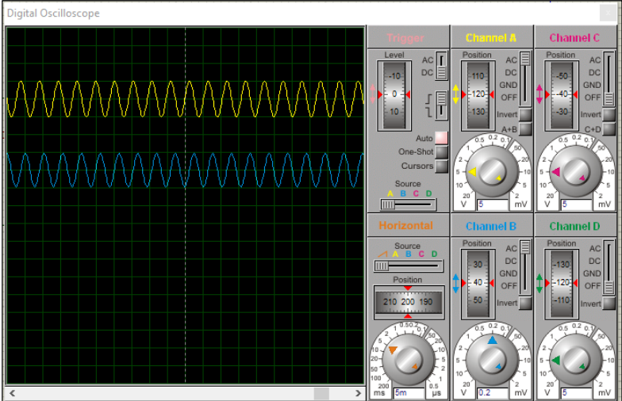

Fig 02

**Procedure:**

* By using Figure 1 with Vin=10Vp-p and R=10kΩ, neglecting capacitor reactance for simplicity. Determine circulating current using measured component values and document in Table 1.
* Construct the circuit per Figure 1 with R=10kΩ and C=1µF. Place probes across the generator and capacitor. Set the generator to a 200 Hz sine wave with 10Vp-p. Enable the Bandwidth Limit on the oscilloscope for both channels for improved accuracy.
* Calculate the theoretical Xc using the measured capacitor value; record in Table 2.
* Record the peak-to-peak capacitor voltage in Table 2.
* Using source current from Table 1 and the measured capacitor voltage, compute and record experimental reactance in Table 2. Also, calculate and record the deviation.
* Repeat steps 3-5 for other frequencies in Table 2.
* Replace the 1µF capacitor with a 2.2µF unit. Repeat steps 2-6, documenting results in Table 3.
* Employ data from Tables 2 and 3 to generate plots illustrating capacitive reactance versus frequency.

**Circuit diagram:**

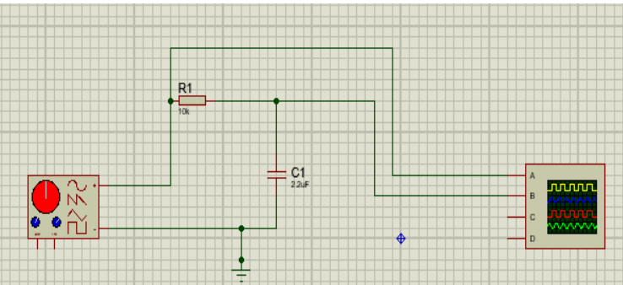

**Calculation and Observations:**

|  |  |
| --- | --- |
| I(p_p) | 0.001A |

## Table # 01

|  |  |  |  |  |  |
| --- | --- | --- | --- | --- | --- |
| **Frequency**  **(Hz)** | **Xc theory**  **(Ω)** | **Vc (p_p)**  **(V)** | **Xc (Exp)**  **(Ω)** | **% Error**  **(%)** |  |
| 200 | 796.17 | 0.8 | 800 | 0.45 |
| 400 | 398.08 | 0.4 | 400 | 0.48 |
| 600 | 265.39 | 0.26 | 260 | 2.15 |
| 800 | 199.04 | 0.2 | 200 | 0.48 |
| 1.0k | 159.23 | 0.16 | 160 | 0.481 |
| 1.2k | 132.69 | 0.13 | 130 | 2.07 |
| 1.6k | 99.52 | 0.1 | 100 | 0.48 |
| 2.0k | 79.61 | 0.08 | 80 | 0.487 |
|  |  |  |  |  |  |

## Table # 02

|  |  |  |  |  |  |
| --- | --- | --- | --- | --- | --- |
| **Frequency**  **(Hz)** | **Xc theory**  **(Ω)** | **Vc (p_p)**  **(V)** | **Xc (Exp)**  **(Ω)** | **% Error**  **(%)** |  |
| 200 | 361.72 | 0.36 | 360 | 0.47 |
| 400 | 180.86 | 0.18 | 180 | 0.487 |
| 600 | 120.57 | 0.12 | 120 | 0.42 |
| 800 | 90.43 | 0.09 | 90 | 0.47 |
| 1.0k | 72.34 | 0.07 | 70 | 3.3 |
| 1.2k | 60.29 | 0.06 | 60 | 0.48 |
| 1.6k | 45.21 | 0.044 | 44 | 2.75 |
| 2.0k | 36.17 | 0.034 | 34 | 5,2 |
|  |  |  |  |  |  |

**Conclusion:**

*In this experiment we examine the capacitive reactance. We observe the relationship between capacitance and frequency. And we also observe theoretical and experimental resistance. By this experiment we also find peak to peak voltage*.